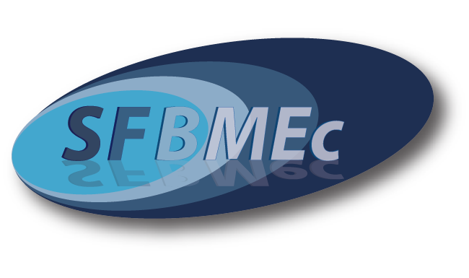
50th Anniversary of the
French Society for Extracellular Matrix Biology
29th-30th March 2012
Fondation Singer-Polignac, Paris, France

Abstract form – Deadline: January 14th 2012

Please save the abstract form as Presentingauthorname.docx and send it by e-mail to s.ricard-blum@ibcp.fr

First name:
Last name:
Institution:
Dept/Lab:
Address:
Phone:
Email:

Presenting author: PhD student Post-doctoral fellow Permanent position

Title in bold
Name of the authors (please underline the name of the presenting author)
Address of the authors

Text in English

