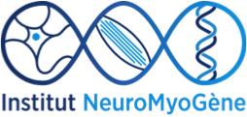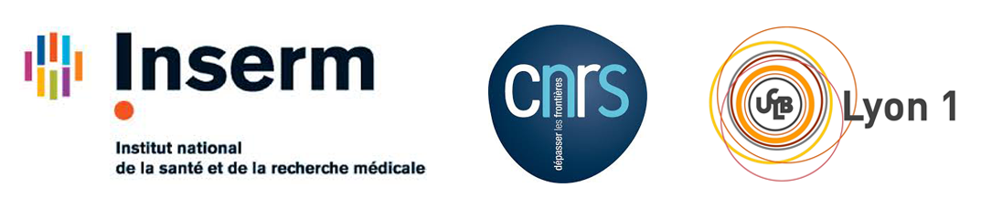

Post-doc position in skeletal muscle matrix environment

The team of Bénédicte Chazaud at Institut NeuroMyoGene at the Université Claude Bernard Lyon 1, CNRS, INSERM, at Lyon, is seeking to fill a postdoctoral research scientist positions in the area of skeletal muscle regeneration and homeostasis. One of the main goals of the Chazaud laboratory research programs is to understand the role of the close environment on muscle stem cell fate in normal regenerating skeletal muscle as well as during muscle diseases.
The research program of the post-doc will focus on the investigation of the extracellular matrix properties in during skeletal muscle regeneration in normal muscle and during muscle diseases.

Requirements
- PhD (or near PhD completion) in biological or biomedical sciences or post-doc scientists with no more than 2/3 years post-doc experience.
- Scientific publications in peer-reviewed journals and presentations at scientific conferences. Published evidence of aptitude for high quality research is essential.
- A strong background or experience in the biology and biochemistry of extracellular matrix is mandatory. A background in skeletal muscle biology is a plus, but not mandatory.

Terms and conditions
The post-doc researcher will conduct and nurture the research program in close connection with the PI, until the submission of high-quality articles. Positions are open from the beginning of 2022. Salary is available for 3 years, renewed every year according to progress, however the post-doc researcher is expected to be involved in obtaining his/her own financing.
Salary: 28-35 k€ gross/year (2.0-2.5 k€ net/month) depending on the previous experience. Social security, pension scheme, insurances are at the charge of the employer.

Environment
The Chazaud team (www.musclestem.com) is an international team benefiting from 100 m2 of office and benches and connected to numerous onsite facilities (molecular biology, imaging, cell biology, physiology). It is part of the Institut NeuroMyoGene (www.inmg.fr), an institute dedicated to basic and translational research in the neuromuscular field that hosts 12 research teams, guaranteeing a high quality and dynamic scientific environment.
As the second biggest town in France, Lyon hosts 60 laboratories in the area of Life and Health Sciences. Lyon is ideally located between the Alps and the Mediterranean Sea. Lyon is renowned for its quality of life including outdoor leisure closely the big city, and of course, its gastronomy and wines.

How to apply?
Please send to the PI: 1) a cover letter highlighting research interests, goals and previous scientific contributions; 2) a CV listing education, publications, meeting presentations and any other skills of interest; 3) at least 2 reference contacts.

Bénédicte Chazaud: benedicte.chazaud@inserm.fr

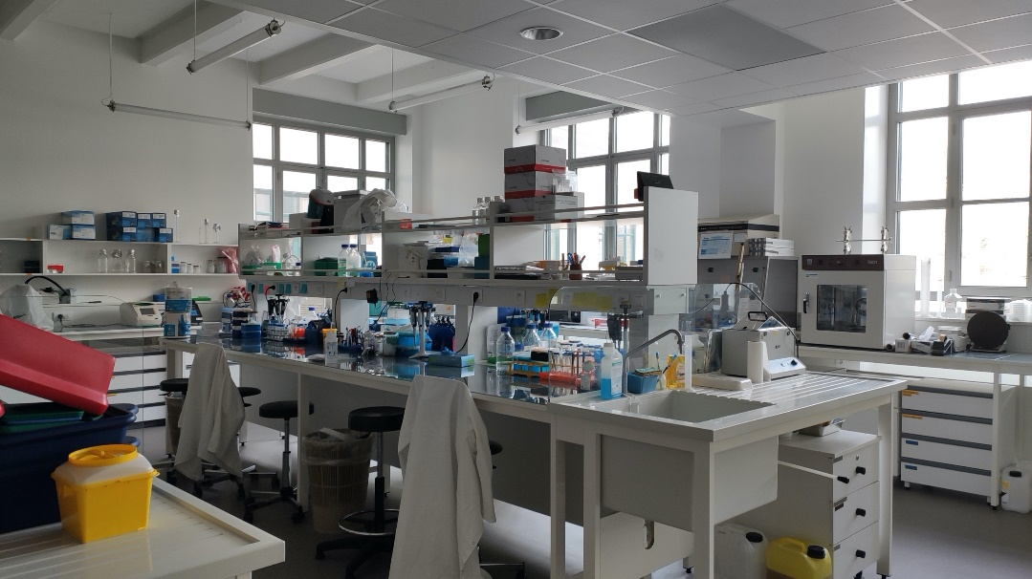
View of old Lyon from the Saone river Partial view of the lab

